**Day 7 - 4/6/2025**

**Barghavi Bethu   
112728766 – bethubal**

**Task 1:**

Create a code to display

“Hello guys!!!! “

“We are learning Java”

Using a single output statement…

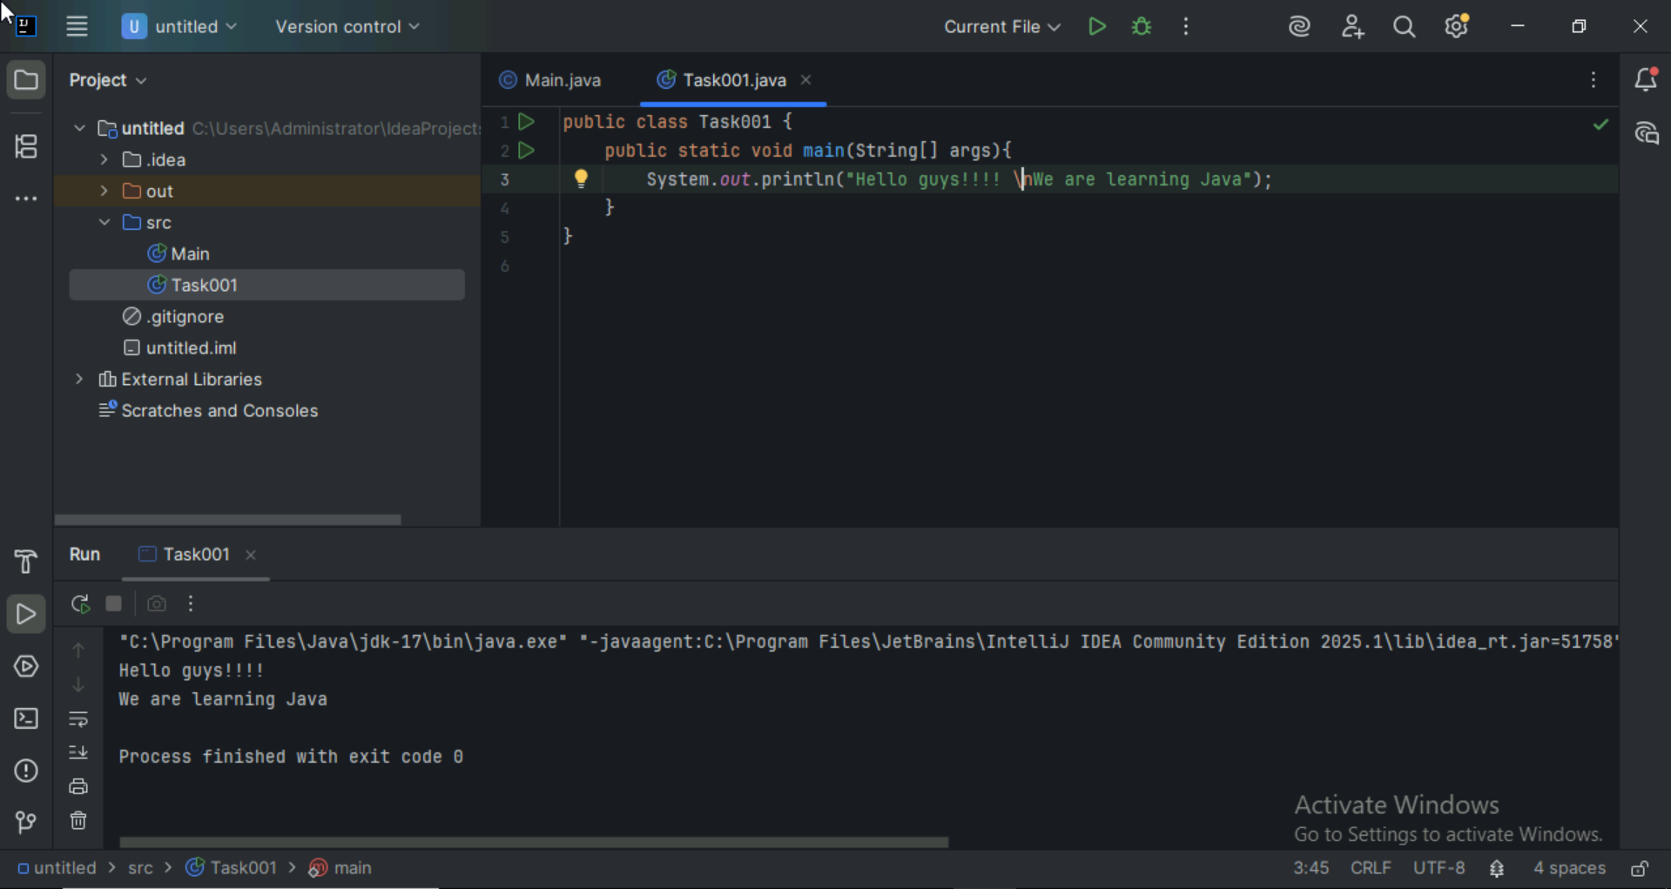

**Task 2:**

Write a Program in Java to Add two Numbers.

Input: 2 3

Output: 5

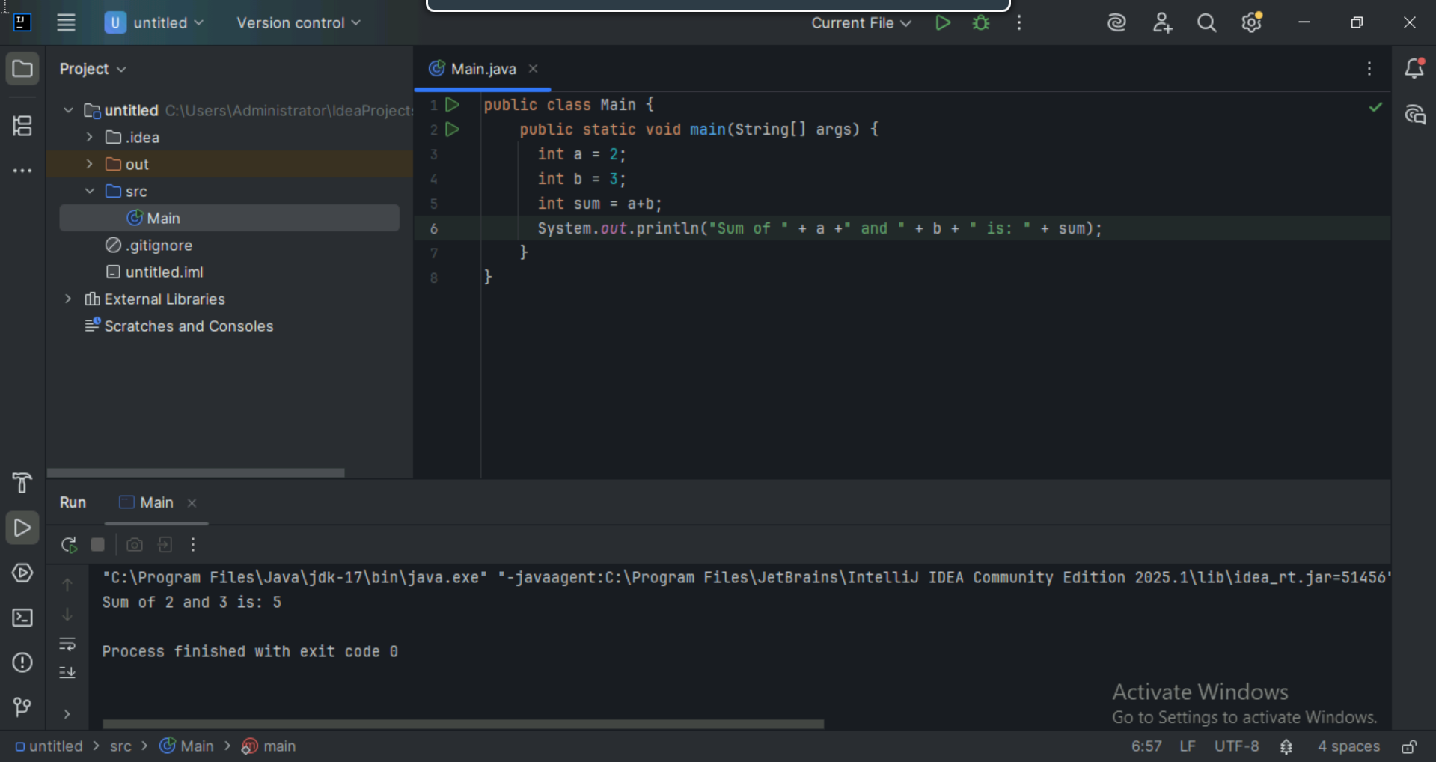

**Task 003:**

Write a Program to Swap Two Numbers

Input: a=2  b=5

Output: a=5  b=2

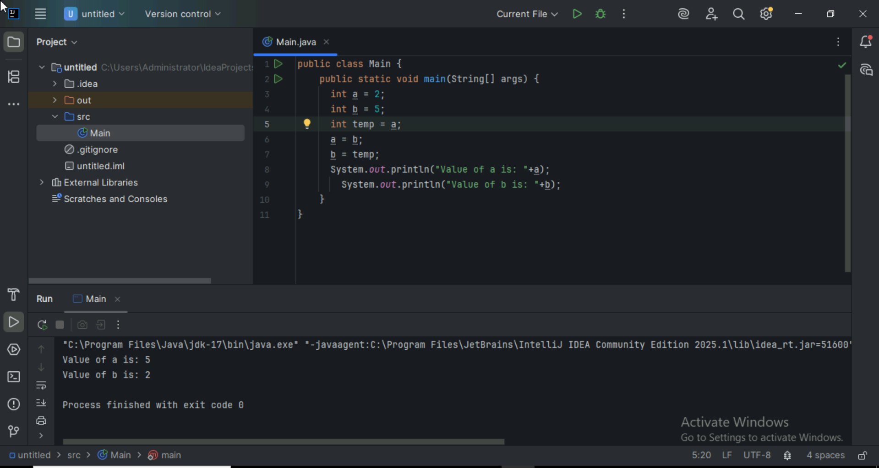

**Task 004:**

 Create a code in which you have 4 methods add, subtract, multiply and divide (return type int) with a main [method..to](http://method..to) all the other methods

Out put:

Main started

Sum of 2 numbers is …..

Diff of 2 numbers is —-

Product of 2 numbers ….

Division of 2 numbers is ….

Main ended

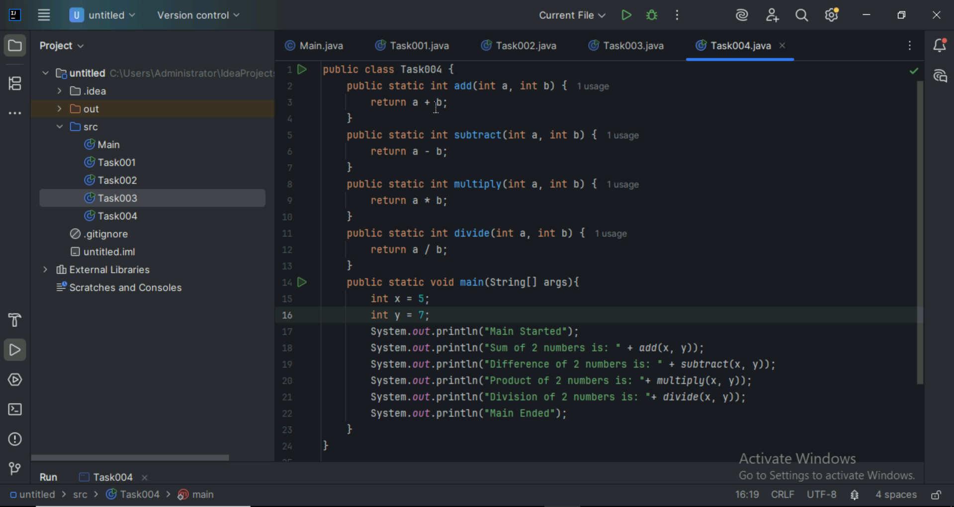

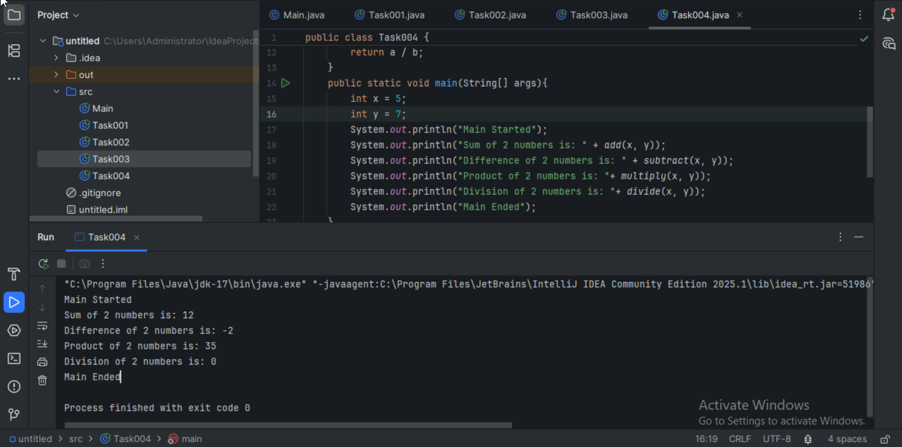

**Task 005:**

Write a program to check if a is greater or b.. Use ternary op

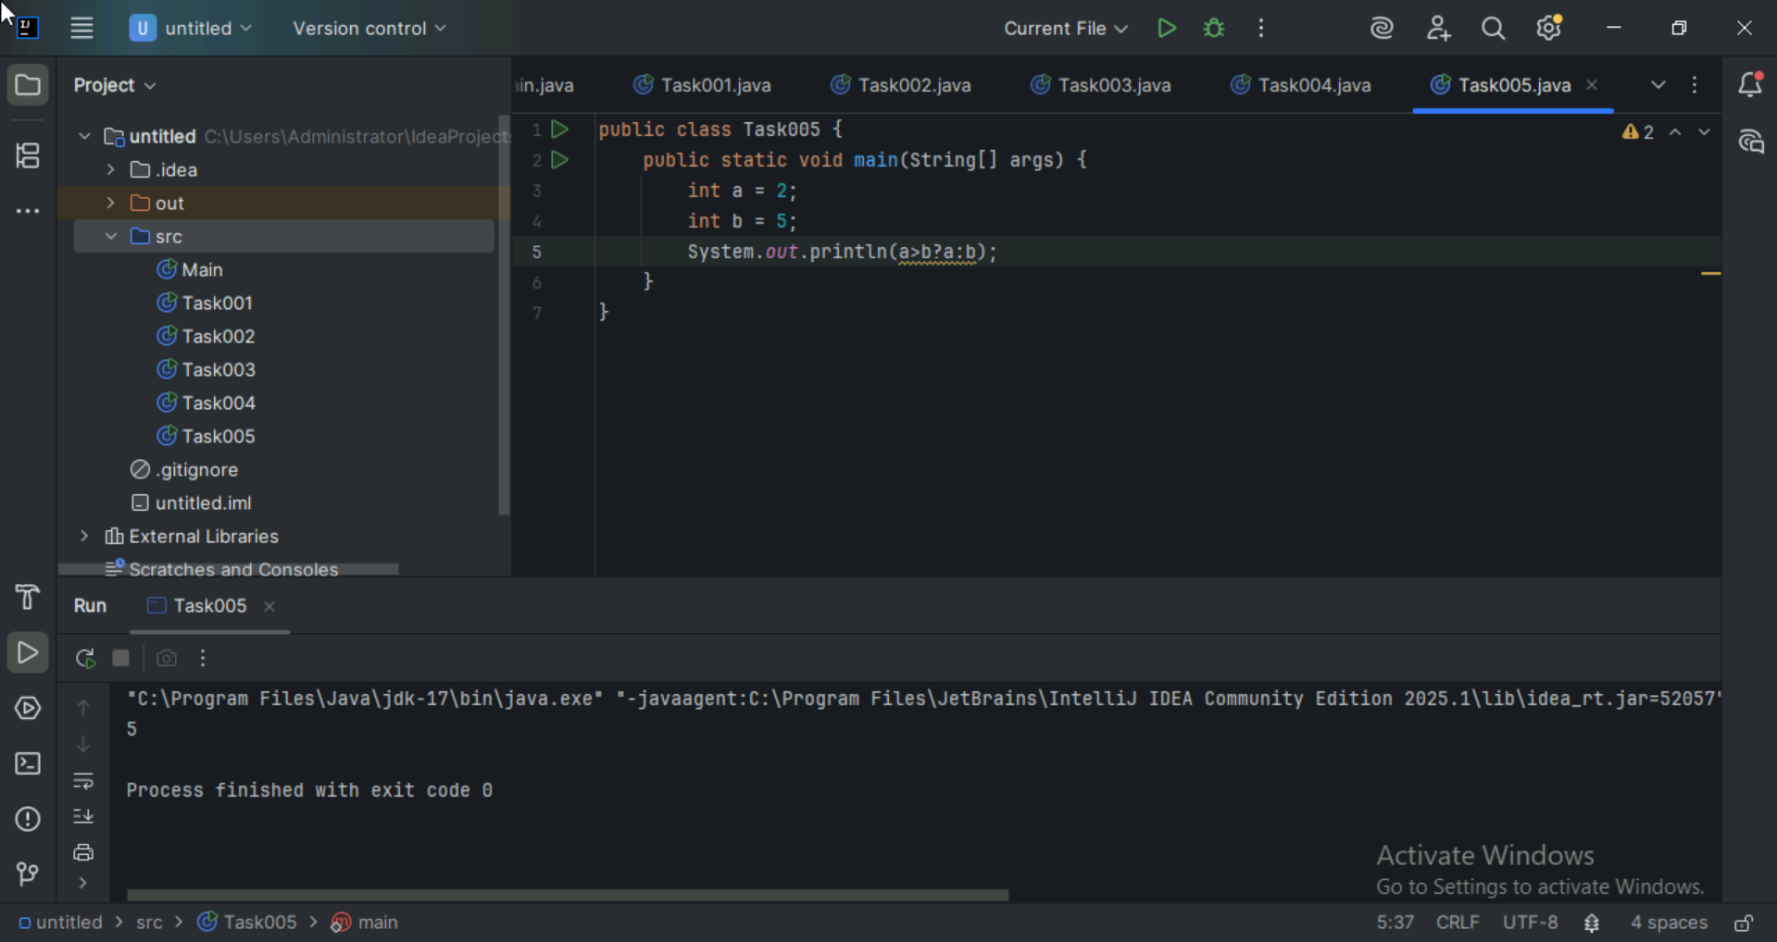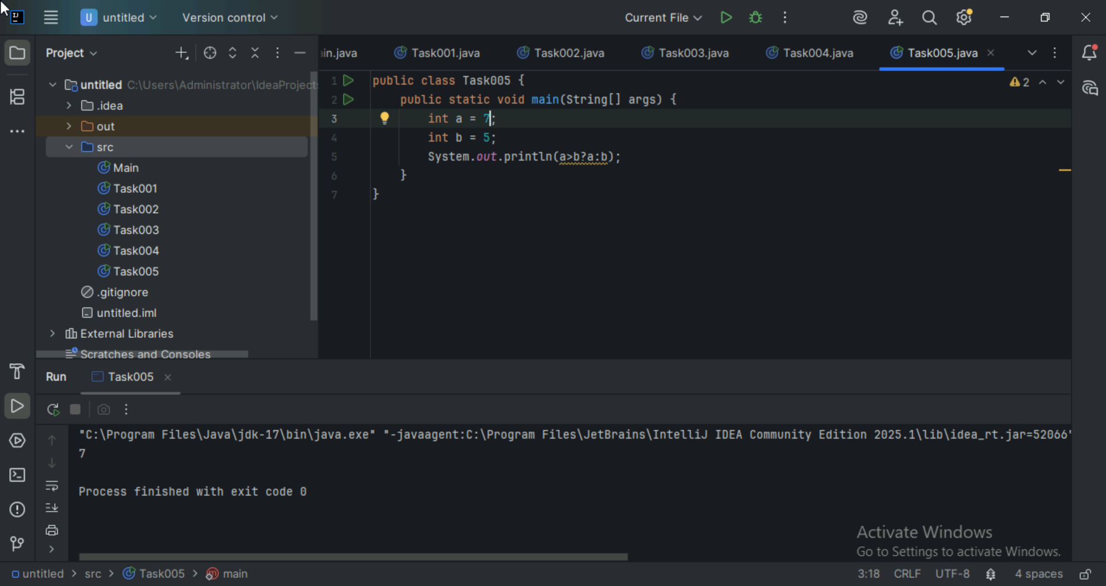

**Task 006:**

Write a program to take input from the user and display it to the user

Input:

Id : Prasunamba

Pwd: 123456789

Output:

Hi ,

Your login id is Prasuanmba

And your pwd is *********

HInt :

For scanner … import java.util.scanner;

Scanner sc = new Scanner([System.in](http://system.in));

Id = sc.nexLine();

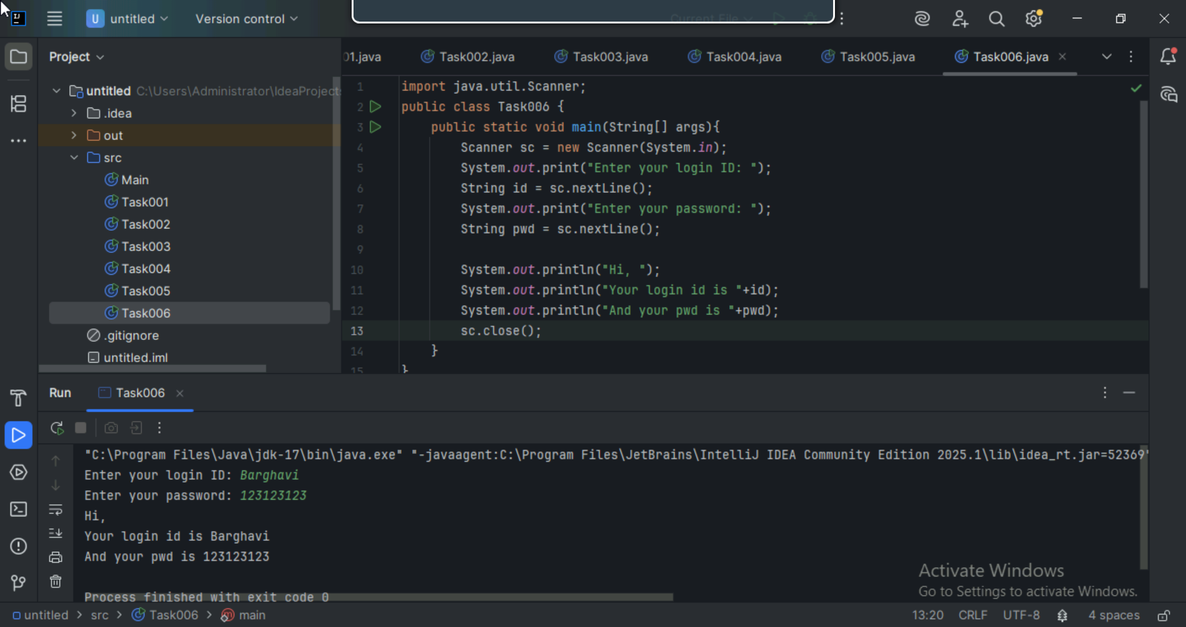

**Task 007:**

Write a program to create a class named Customer

Call the customer class in Task007 class using an object

Hint

Class Customer{

  Void accept(){

sysout(“accept customer called”);

}

Void display(){

sysout(“display customer called”);

}

}

Public class Test007{

psvm(String[] argos){

Customer cobj = new Customer();

cobj.accept();

cobj.display();

}

}

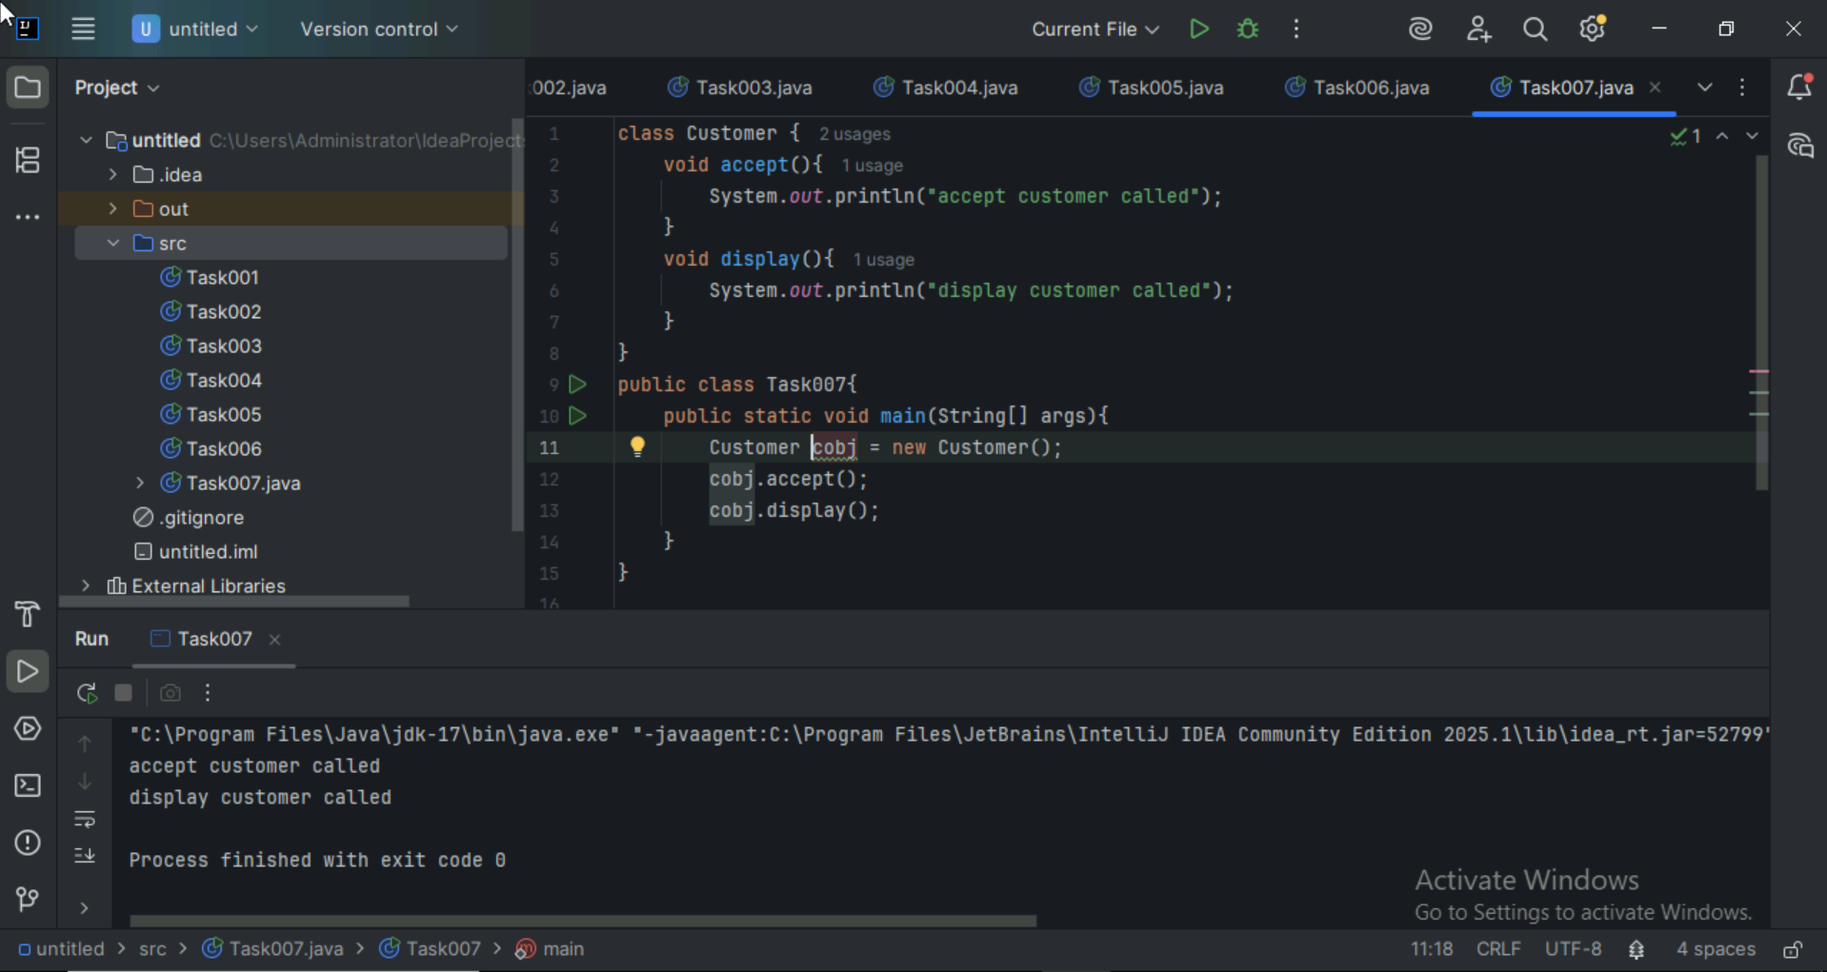

**Task 008:**

Wap to check the greater of 2 numbers

Hint:

Use if else

If ( num1 > num2){

sout(“num1 is greater”);

}

Else {

sout(“num2 is greater”);

}

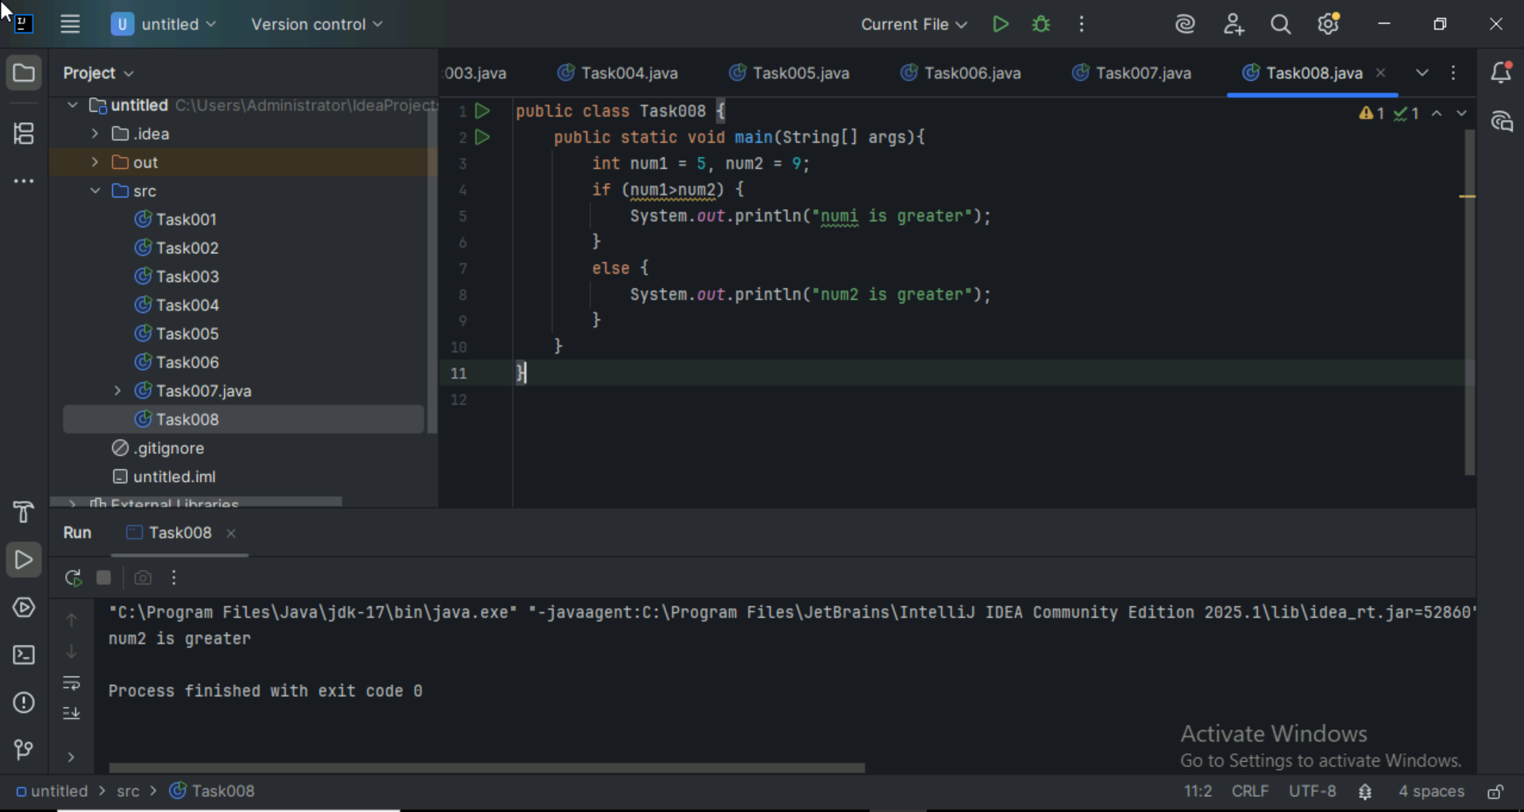

**Task 009**

Wap to check greater than 3 numbers

Hint 👍

Use elseif

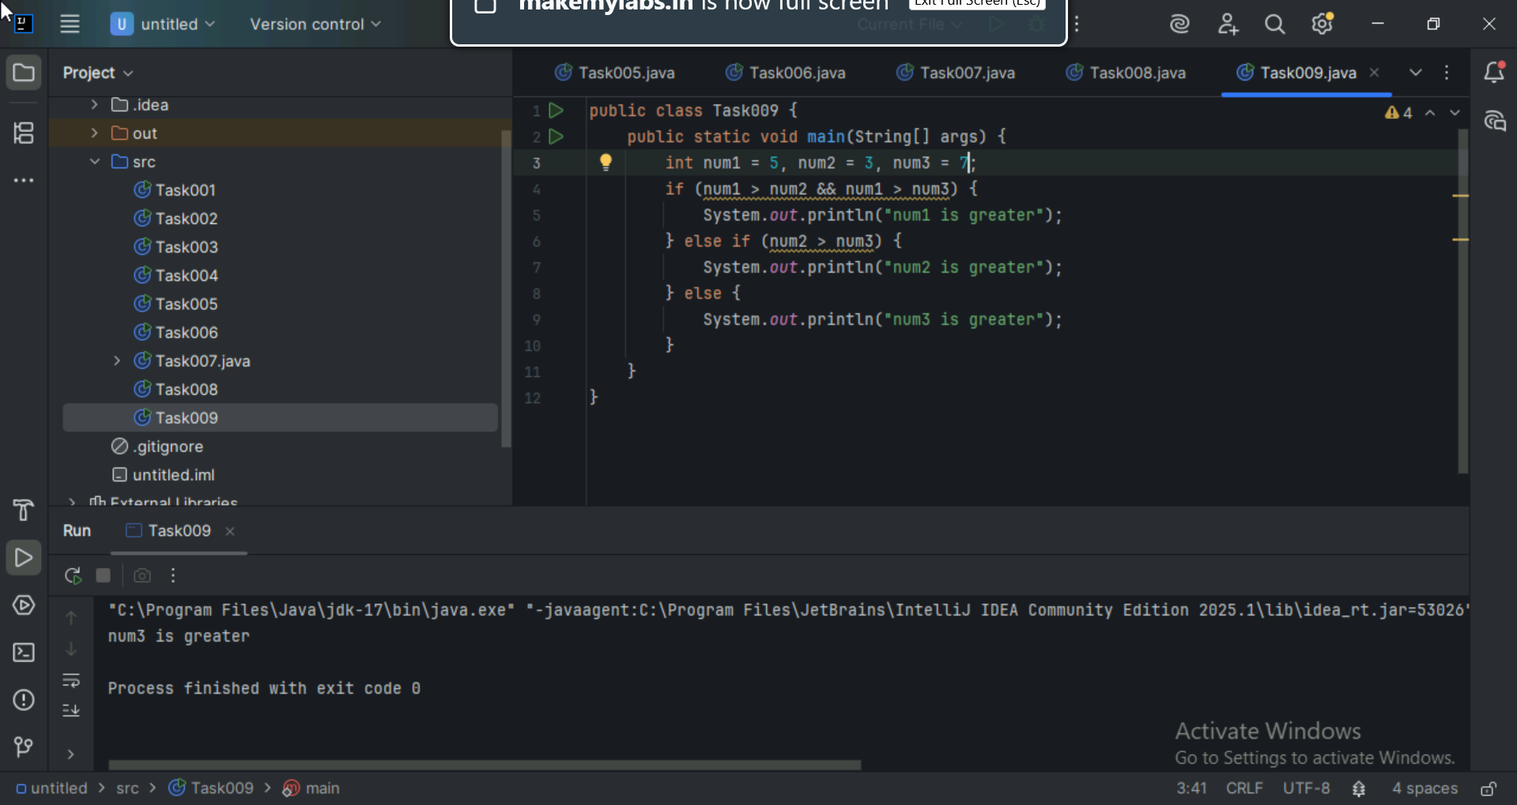

**Task 010:**

Wap to check if check week days

1  ===> sunday

2 ===> monday

So on

8 and above ===> invalid input

Hint : use Switch case

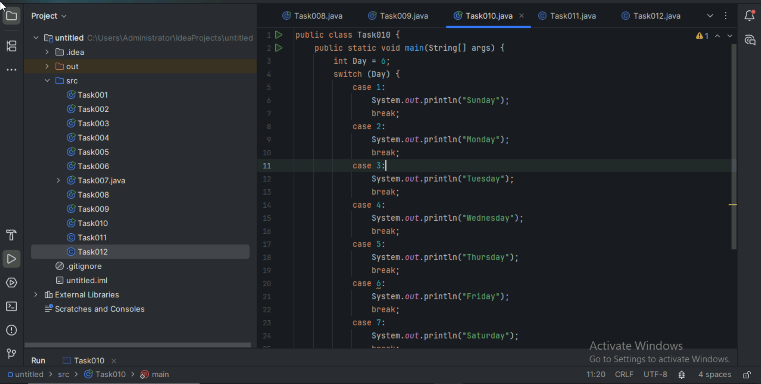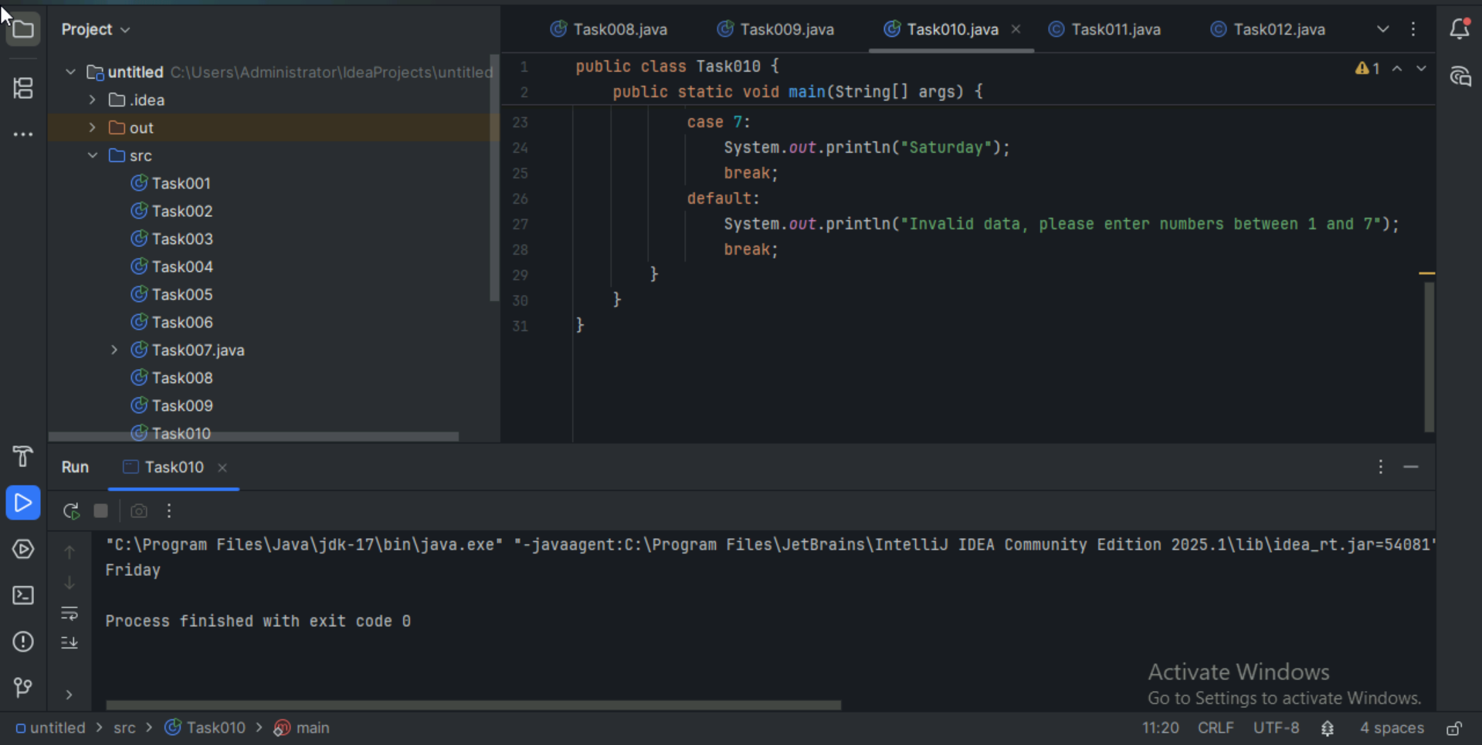

**Task 011:**

Wap to check loginid and password validation

Hint use while loop

Scanner sc = new Scanner(System.in);

String loginid = “Prasunamba”

String pwd = “12345867”

Int Count = 0;

While (loginid == “Prasunamba” && pwd == “12345867”){

sout(“ you have logged in for  ”+ count++ +” times”);

sout(“enter ur login id and password”);

loginid = sc.NextLine();

pwd = sc.NextLine();

}

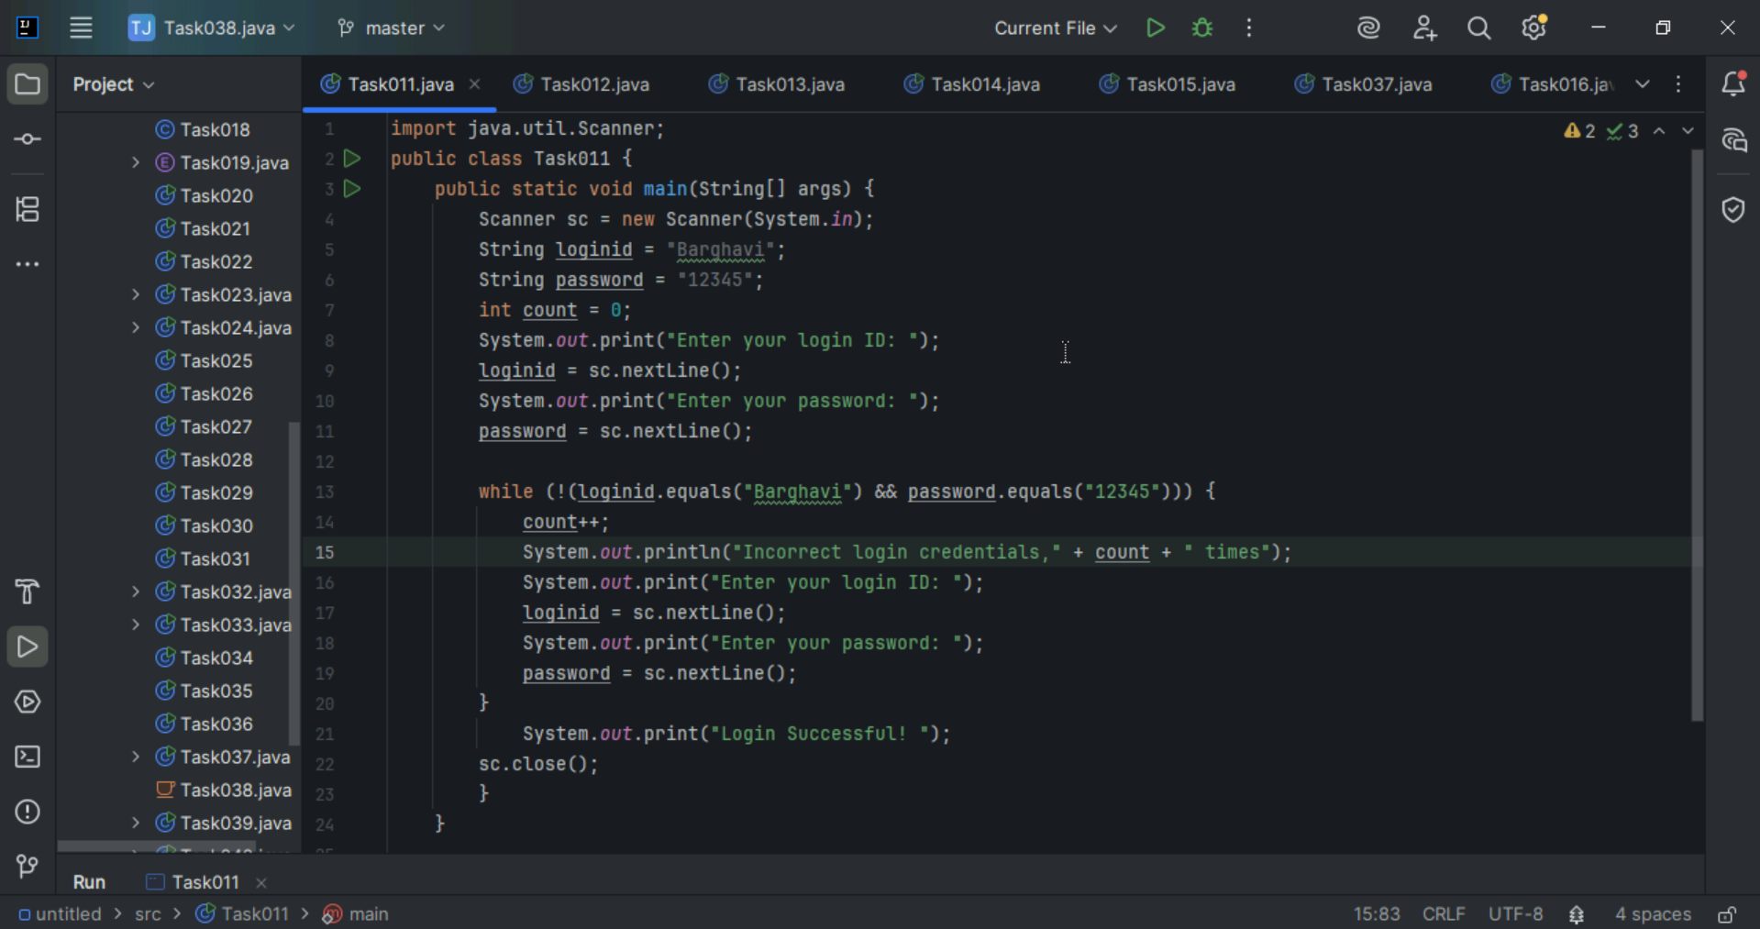

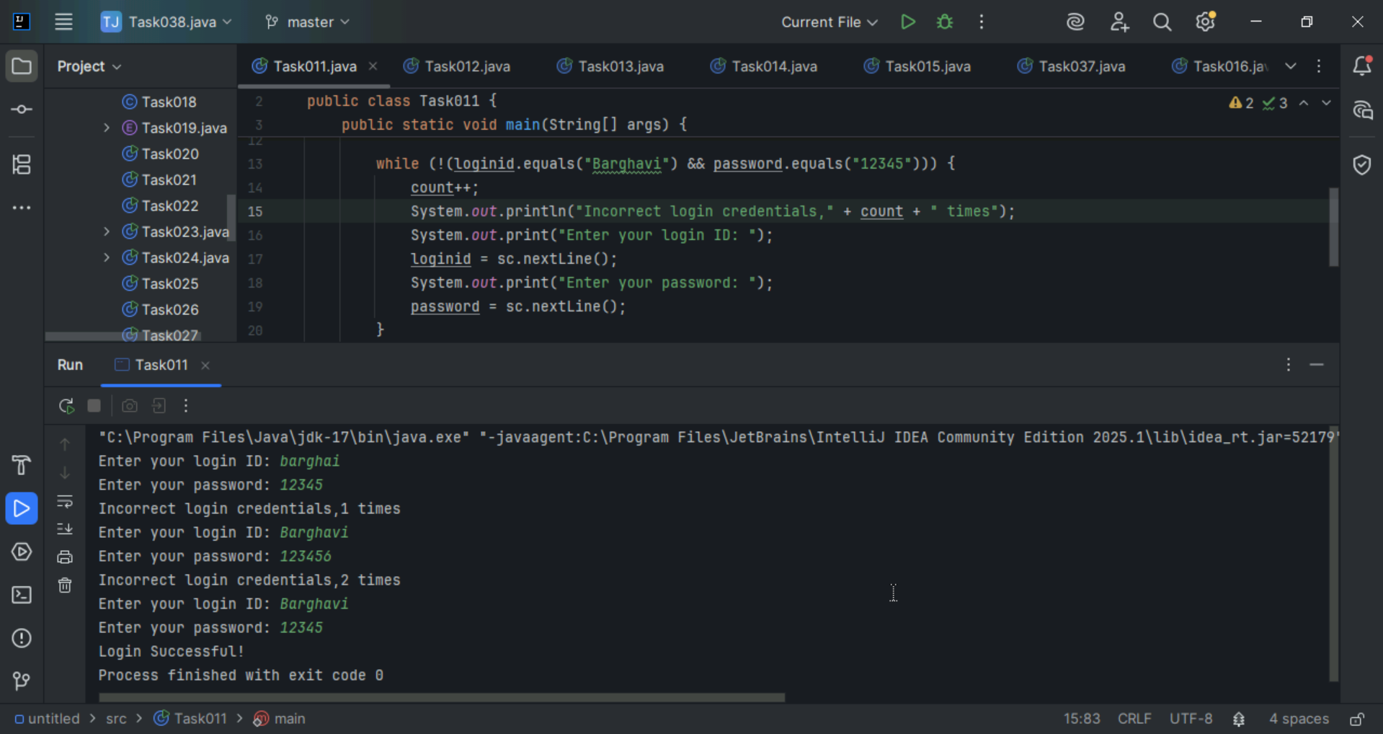

**Task 012:**

Same as above qn but use do while loop

Scanner sc = new Scanner(System.in);

String loginid = “Prasunamba”

String pwd = “12345867”

Int Count = 0;

do{

sout(“ you have logged in for  ”+ count++ +” times”);

sout(“enter ur login id and password”);

loginid = sc.NextLine();

pwd = sc.NextLine();

}While (loginid == “Prasunamba” && pwd == “12345867”);

sc.close();

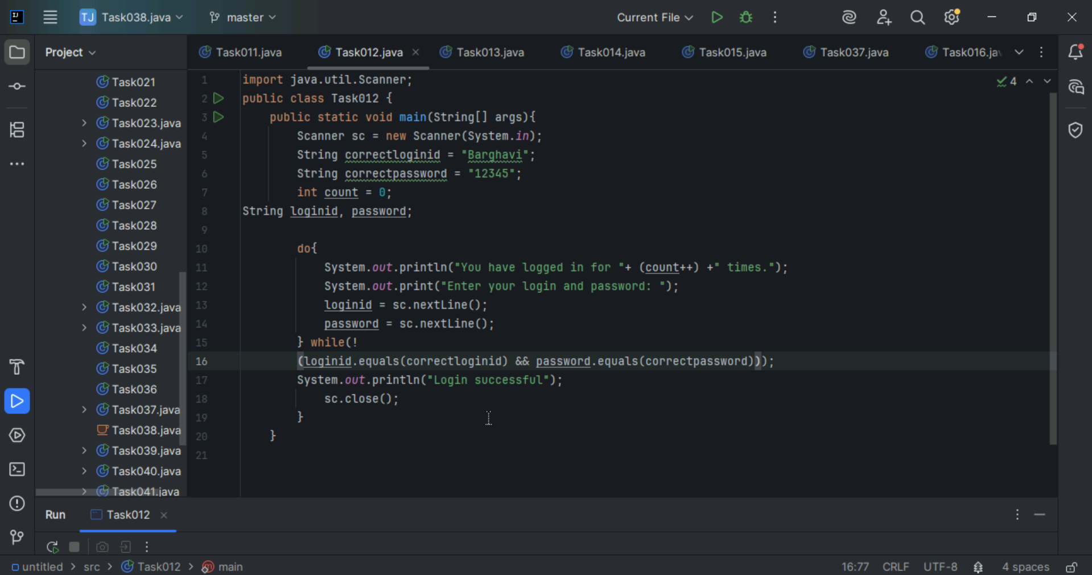

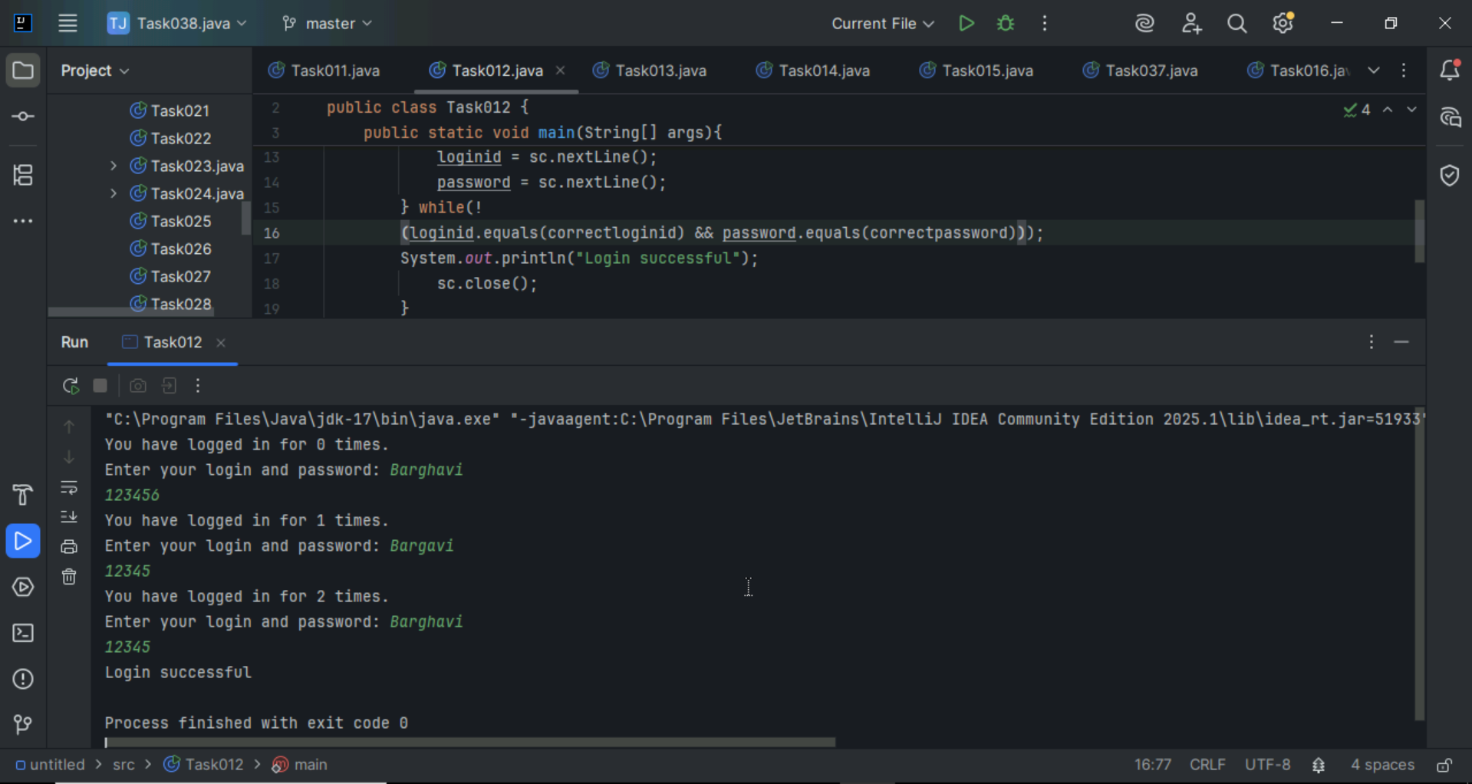

**Task 013:**

Wap to display numbers from 10 to 1 .. skip 7 and 5.

for(int i= 10; i >0; i–){

If ( i == 5 || i == 7){

Continue;

sout(i);

}

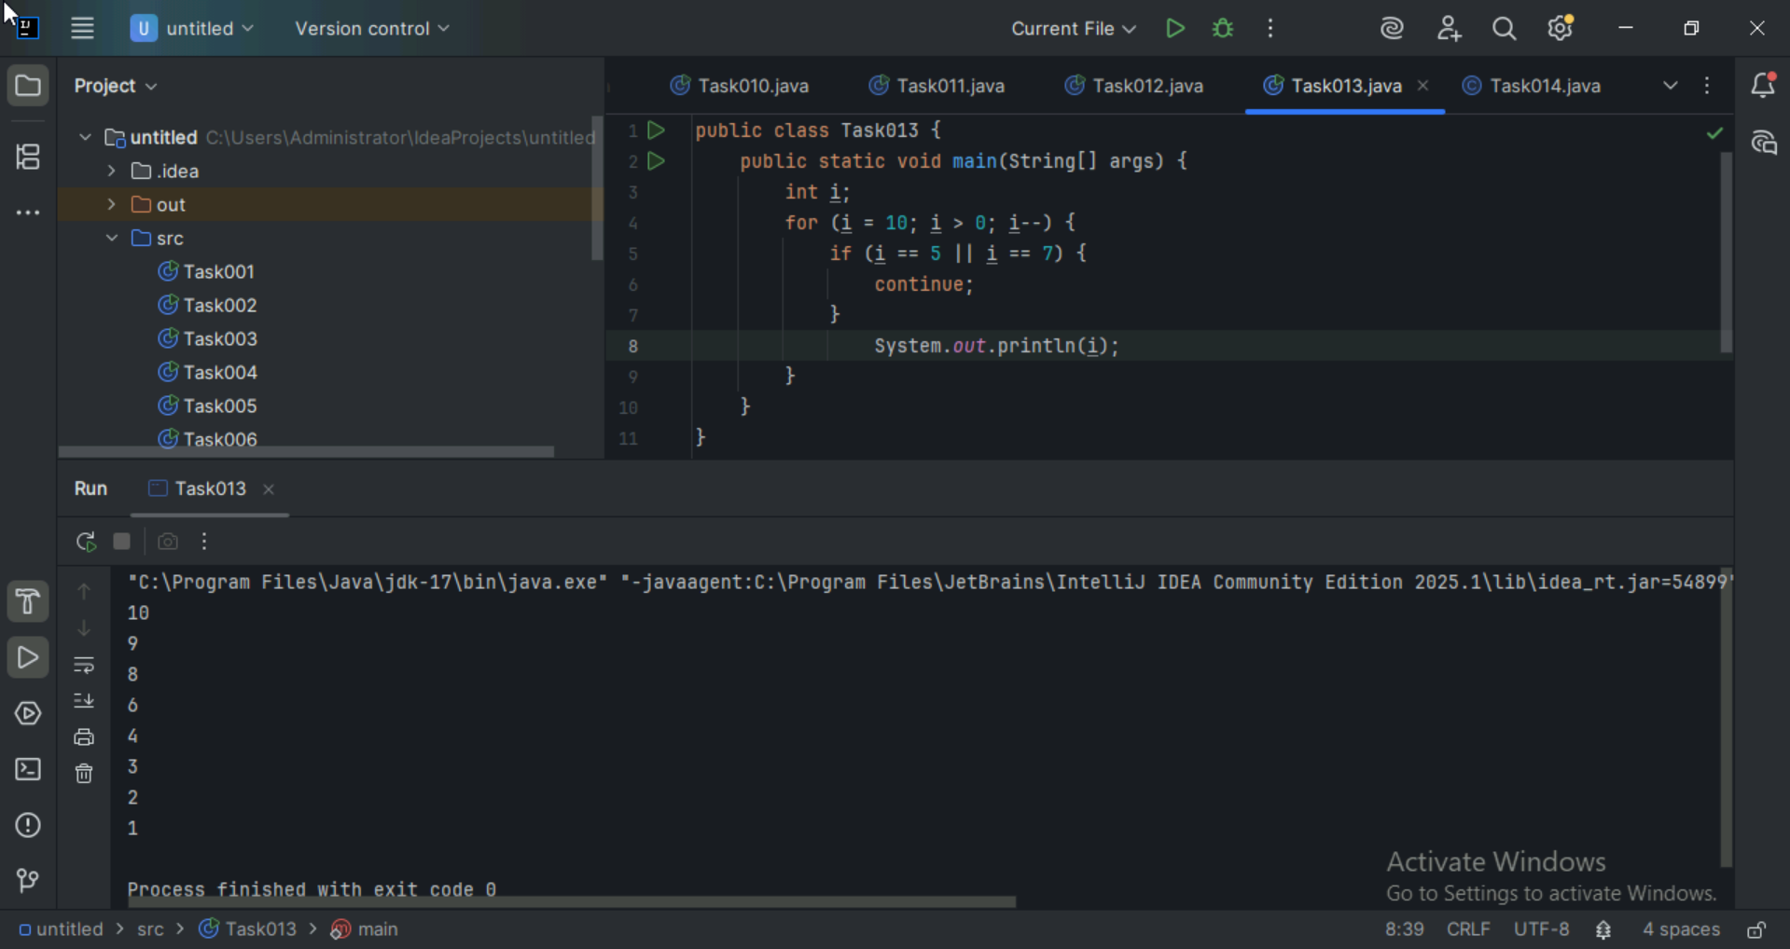

**Task 014:**

Arrays:

Try the below code and display the output…

Now play with it try to access 5th index and see the output…and try to access -1 index and see the output..

package Arrays;

public class Demo01 {

public static void main(String[] args) {

// TODO Auto-generated method stub

char[] arr = {'a','e','i','o','u'};

System.out.println(arr);

String[] names = {"Meena", "Tina", "Veena", "heena"};

System.out.println(names[0]);

names[1]= "Reena";

System.out.println(names[1]);

System.out.println(names.length);

System.out.println(names[4]);

//Exception in thread "main" java.lang.ArrayIndexOutOfBoundsException

}

}

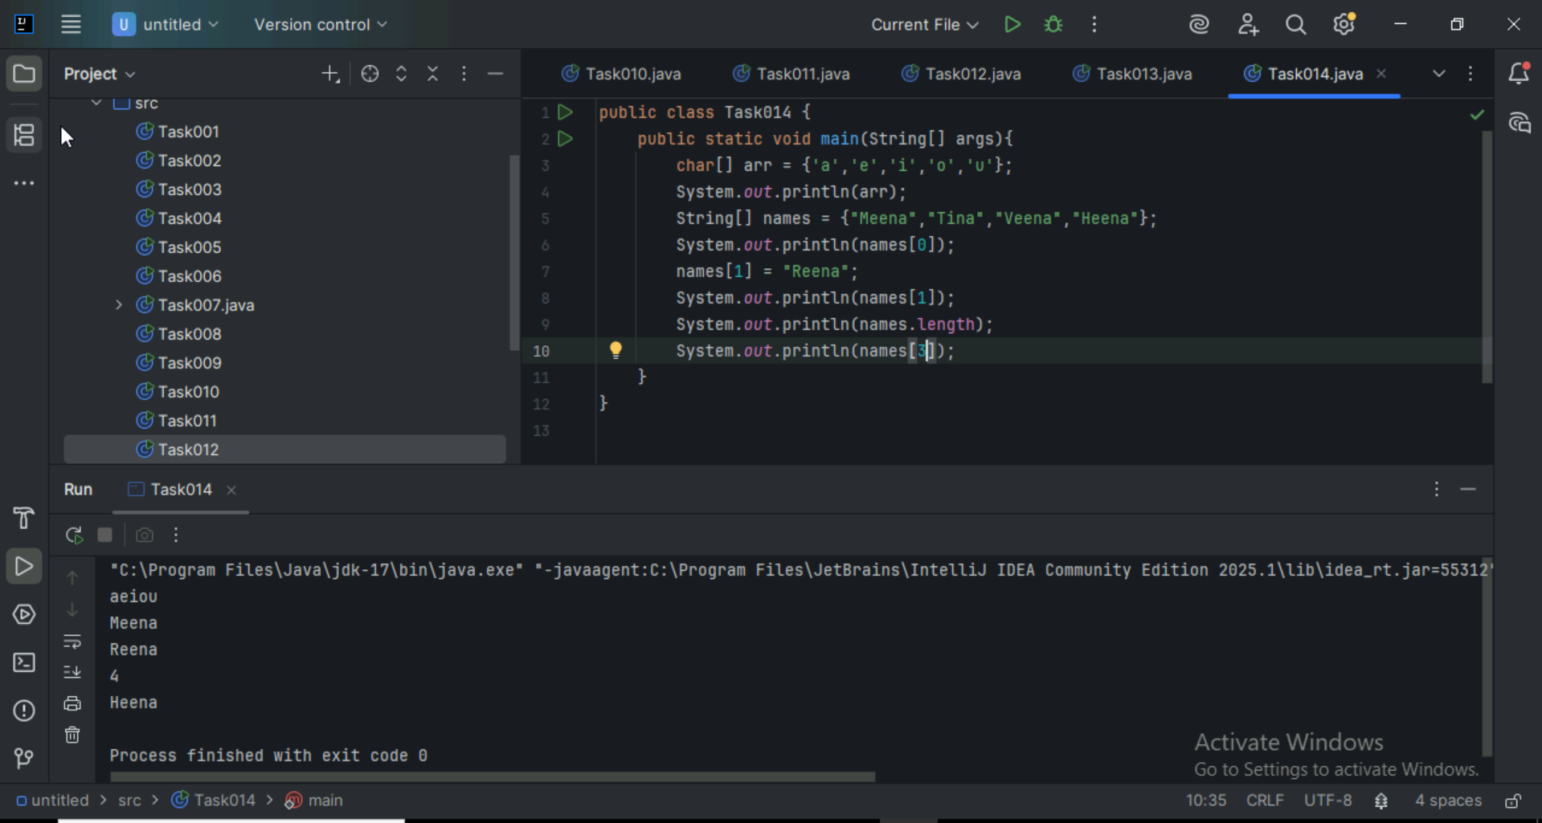

Strings:

**Task 015:**

package StringHandling;

public class Demo01 {

public static void main(String[] args) {

// TODO Auto-generated method stub

String str1 = "Java Strings "; // string Literal

String str2 = new String(str1); // obj of the string - new keyword

String str3 = new String("are easy to learn ");

char ch[] = {'S', 't', 'r' ,'i', 'n', 'g'};

String str4 = new String(ch);

System.out.println(str1 + "\n" + str2 + "\n" +str3 + "\n" +str4);

}

}

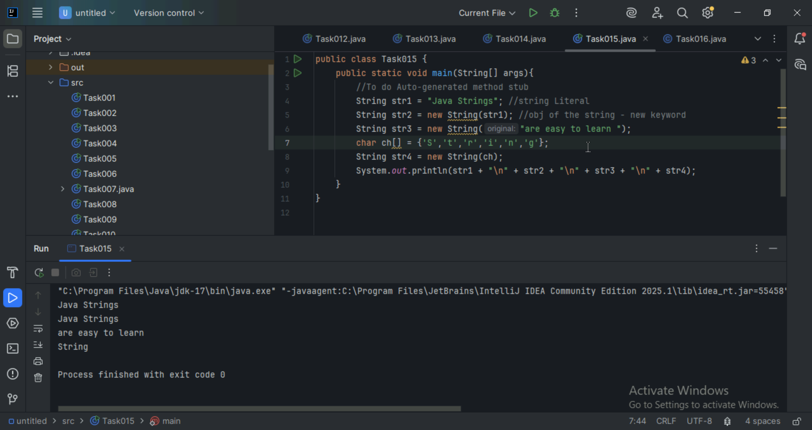

**Task 016**

Enums or Enumerations

What is the output of the below code snippet

package Enumerations;

enum color{

red, blue, green, yellow

}

public class Demo01 {

public static void main(String[] args) {

color c1 = color.yellow;

System.out.println(c1);

}

}

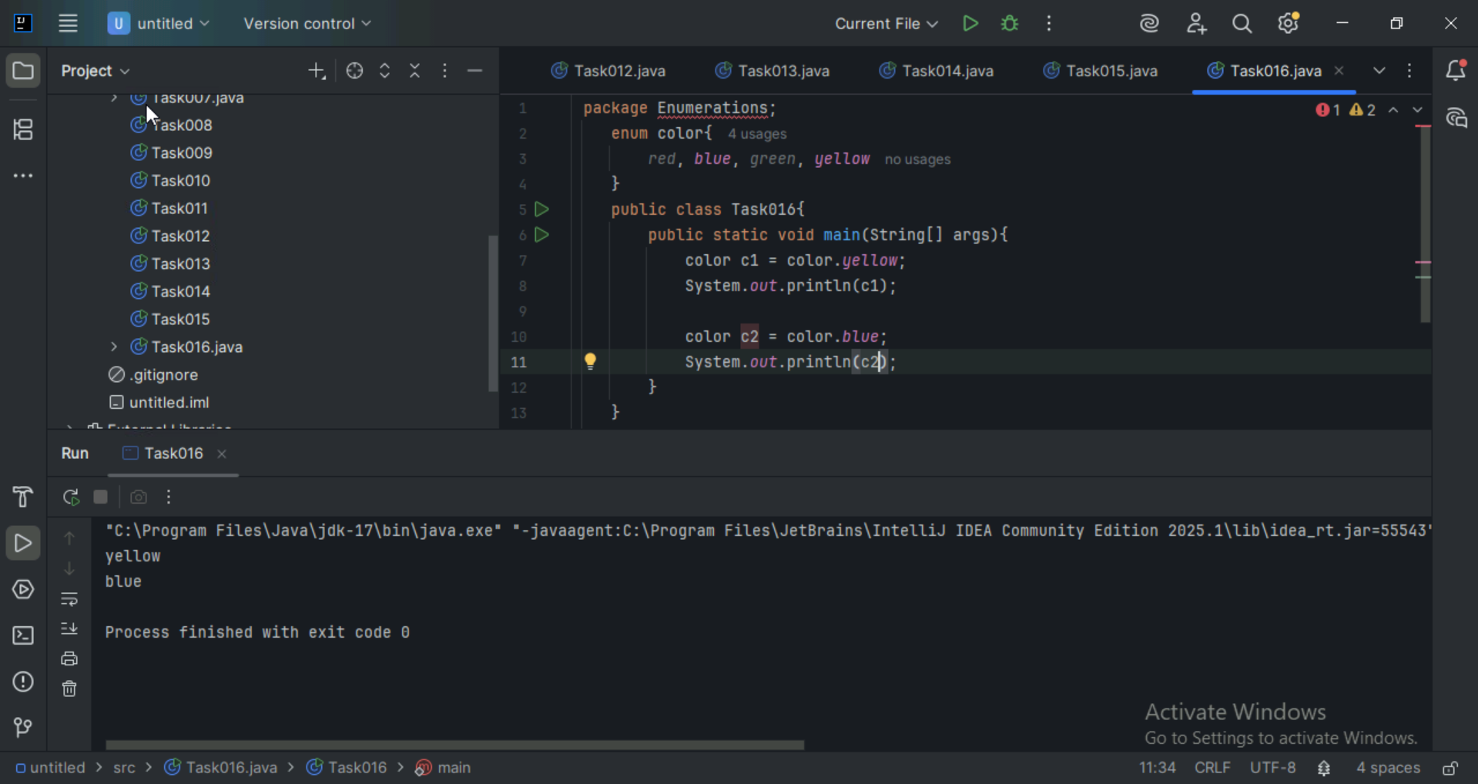

**Task 017:**

Getter and setter

Create a program name Person.java

public class Person {

   private String name;

   // Getter

   public String getName() {

     return name;

   }

   // Setter

   public void setName(String newName) {

     this.name = newName;

   }

}

Create another program named Task017.java

public class Task017{

  public static void main(String[] args) {

    Person myObj = new Person();

    myObj.name = "John";

    System.out.println(myObj.name);

  }

}

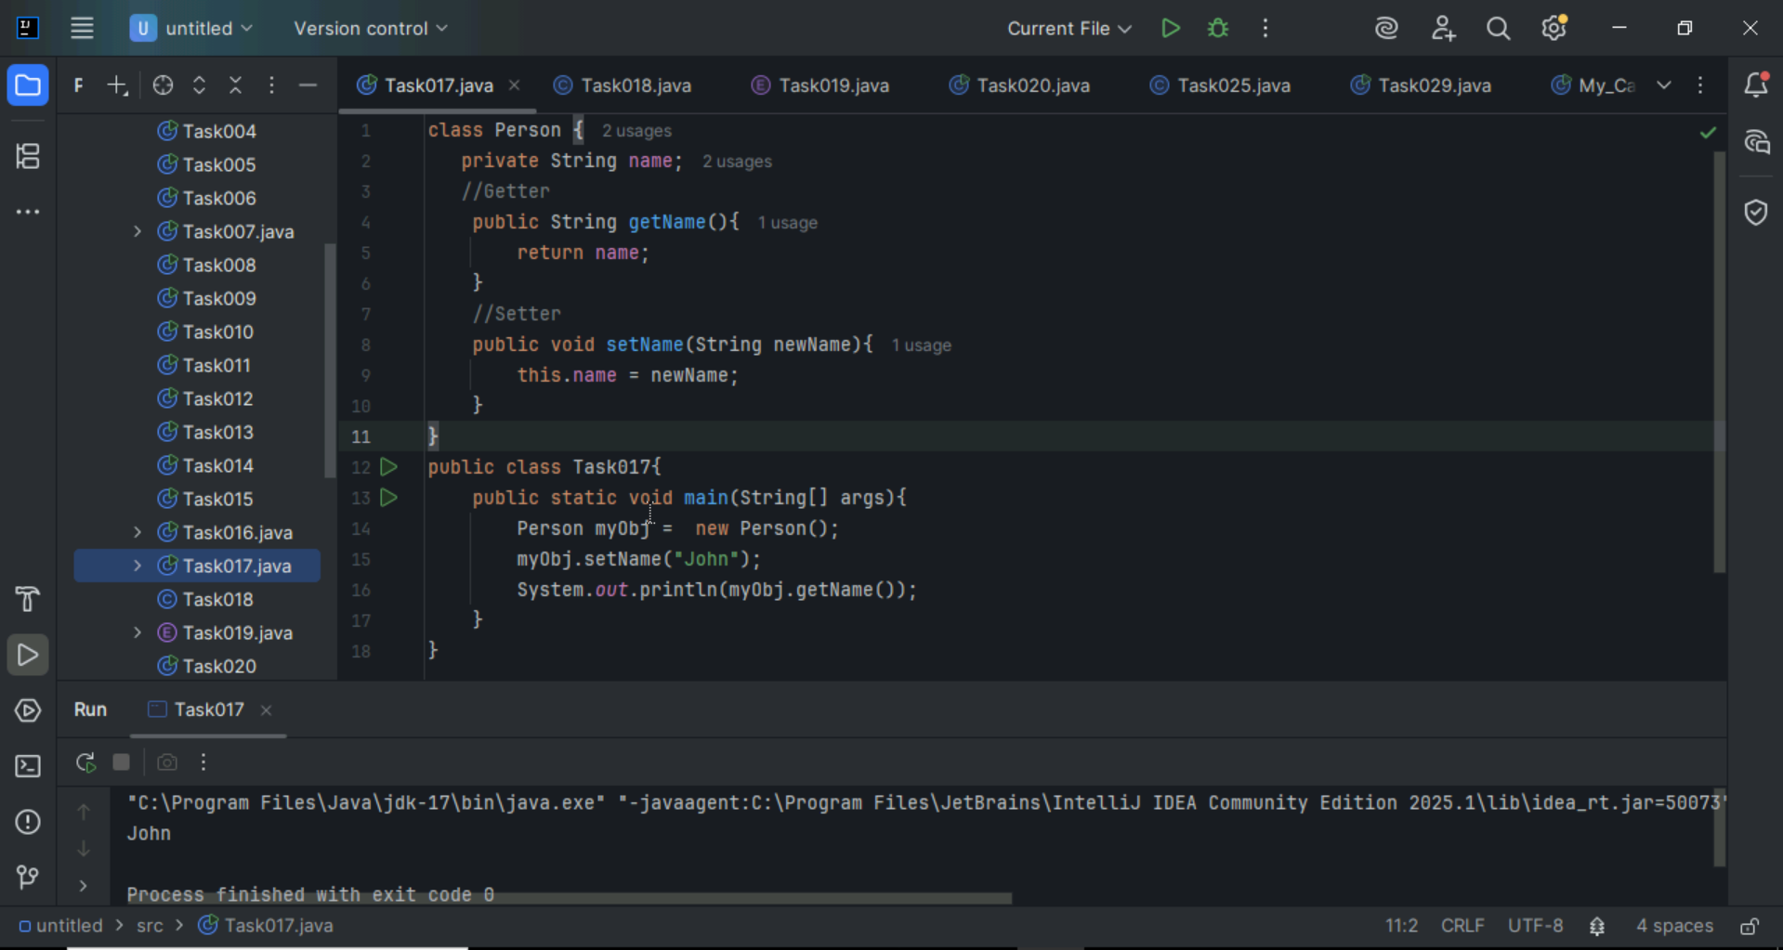

**Task 018**

Now create one more program named Task018.java

public class Main {

public static void main(String[] args) {

Person myObj = new Person();

myObj.setName("John");

System.out.println(myObj.getName());

}

}

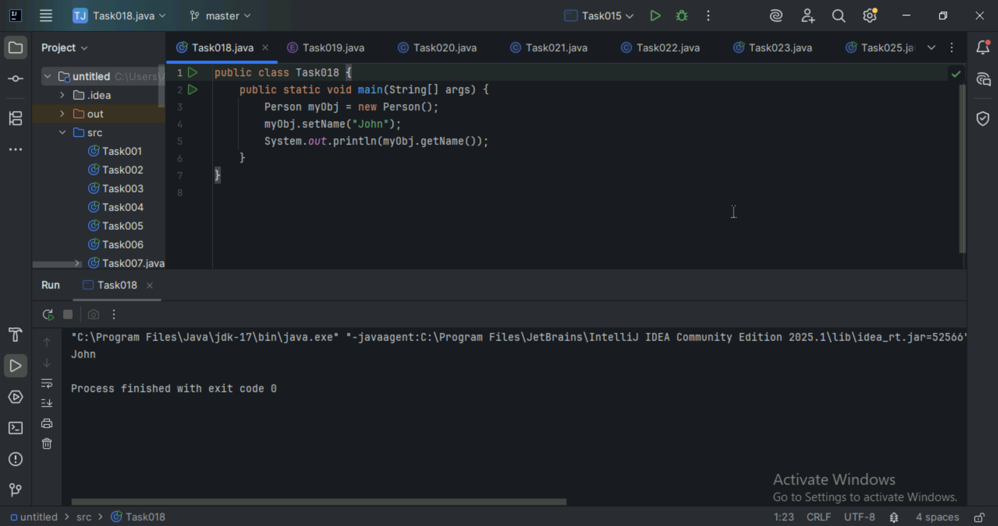

**Task 19:**

//Attaching Multiple values

public enum Element {

    H("Hydrogen", 1, 1.008f),

    HE("Helium", 2, 4.0026f),

    // ...

    NE("Neon", 10, 20.180f);

    private static final Map<String, Element> BY_LABEL = new HashMap<>();

    private static final Map<Integer, Element> BY_ATOMIC_NUMBER = new HashMap<>();

    private static final Map<Float, Element> BY_ATOMIC_WEIGHT = new HashMap<>();

    static {

        for (Element e : values()) {    //for each loop

            BY_LABEL.put(e.label, e);

            BY_ATOMIC_NUMBER.put(e.atomicNumber, e);

            BY_ATOMIC_WEIGHT.put(e.atomicWeight, e);

        }

    }

    public final String label;

    public final int atomicNumber;

    public final float atomicWeight;

    private Element(String label, int atomicNumber, float atomicWeight) {

        this.label = label;

        this.atomicNumber = atomicNumber;

        this.atomicWeight = atomicWeight;

    }

    public static Element valueOfLabel(String label) {

        return BY_LABEL.get(label);

    }

    public static Element valueOfAtomicNumber(int number) {

        return BY_ATOMIC_NUMBER.get(number);

    }

    public static Element valueOfAtomicWeight(float weight) {

        return BY_ATOMIC_WEIGHT.get(weight);

    }

}

Wap to display the content of the above enum.. (main  needs to be added)

